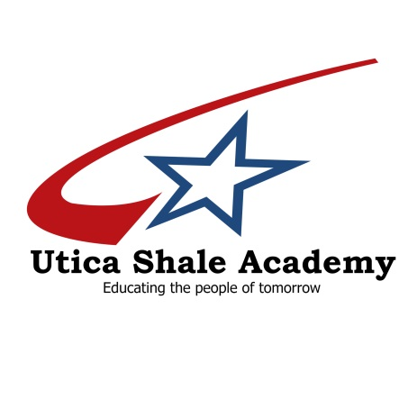

BOARD OF EDUCATION
Dr. Charles Joyce, President
William Pitts
Christina Wanat
Larry Mayle
Mike Biasi
Don Donahue, Treasurer

38095 State Route 39
Dr. George Ash, Chief Executive Officer
740-283-3347
Dr. Chuck Kokio, Superintendent
740-283-3347
Eric Sampson, Director
330-679-8162

Salineville, Ohio 43945
330-679-8162
Fax 330-679-3005
www.uticashaleschool.com

Parents/Guardians,

The end of the school year is fast approaching. Along with that, so too is graduation. Graduation is scheduled for Thursday, May 26th in the Southern Local High School gymnasium. A free banquet dinner will be served at 6:00 pm with graduation to follow. I will contact you for dinner reservations at a future date.

Cap and gown orders are due by April 15th. Orders can be placed at Jostens.com. Enter Utica Shale Academy in the School/Group search box. Click on Cap and Gowns in the menu to the right. Scroll down to the bottom of the page to order your cap and gown. All cap and gowns are black with red/white/blue tassels. Tassels are included and do not need to be purchased separately.

All coursework must be completed by May 25th. Any lessons not completed will be given zeros and final grades averaged accordingly. It is imperative that students complete their lessons/courses prior to the last day of school in order to graduate.

With only a few weeks left, graduation will be here before we know it. Please encourage your senior to get their cap and gowns ordered prior to April 15th, and to get all of their course work out of the way.

Please contact me if you have any questions.

Thank you,

Eric Sampson

Director

