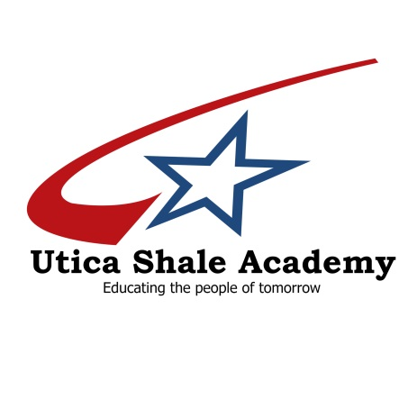

BOARD OF EDUCATION

Mark Johnson, President
Mike Biasi
Barry Gullen
Dr. Charles Joyce
William Pitts
Phillip Hinson, Treasurer

38095 State Route 39

Dr. Mark Furda, Superintendent
330-420-5353
Eric Sampson, Director
330-420-5353

Salineville, Ohio 43945
330-420-5353
Fax 330-679-3005
www.uticashaleschool.com

College Credit Plus

Students at the Utica Shale Academy have an opportunity to attend local colleges, free of charge, to earn college and high school credits toward graduation. USA has agreements with Stark State University and Eastern Gateway Community College that allow students to attend college courses while still enrolled in highs school. Call USA to speak to the director to find out more information.

