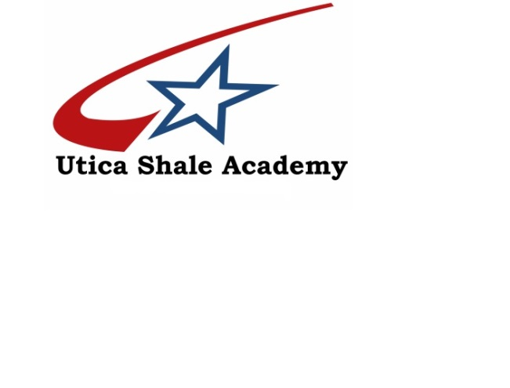

2016-2017
Annual Report

Overview
The Utica Shale Academy completed its third year of educating students in May of 2017. 65 full-time students were enrolled at the end of the year attending school at two locations; Southern Local High School and Columbiana High School. USA staff included the director, one teacher and two tutors.
Demographics
99% of the 71 students enrolled in USA were Caucasian. >1% of the students were of a heritage other than Caucasian. These totals equated to 69 Caucasian students and 2 (>1%) African American students. Overall, 77% or 54 students qualified for the free/reduced lunch program for the 2016-17 school year at USA. 71% of the students qualified for the free lunch program. 4% of the students qualified for a reduced rate lunch.
26% of the students attended under an Individualized Education Program (I.E.P). 19 students had an I.E.P

Graduation
24 total students earned diplomas in 2017. The graduation rate for USA for 16-17 is 100%.
Testing
Over the course of the school year, including testing in the fall, spring, and summer, students participated in state standardized testing. Ohio Graduation Tests (OGT) results for all grades and tests taken are as follows:
Writing- 55.5% Math- 71.4% Social Studies- 55.5%
Reading- 75% Science- 100%

Students also participated in AIR testing science and social studies. The testing results for all grades and tests taken are as follows:

American Government- 21 total students with 5 (23.8%) scoring proficient or higher.
American History- 22 total students with 4 (18%) scoring proficient or higher.
Geometry- 1 students with 0 (0%) scoring proficient or higher.
Biology- 20 total students with 3 (14%) scoring proficient or higher
Language Arts 1- 23 total students with 13 (56.5%) scoring proficient or higher.
Language Arts 2- 23 total students with 9 (39%) scoring proficient or higher.
Integrated Math 1- 24 total students with 3 (12.5%) scoring proficient or higher.
Integrated Math 2- 20 total students with 1 (5%) scoring proficient or higher.
Writing- 29% Math- 31% Social Studies- 37%
Reading- 62% Science- 65%

Academics
Through its unique blended learning structure, USA is able to aid in course recovery for students. For the 2016-2017 school year, 18 students were able to recover credits and return to being on track to graduate in four years. 13 of the 24 graduates were able to earn their high school diplomas after being more than a year behind schedule when entering USA.
The Virtual Learning Academy catalogue of courses utilized by USA enables students to build a customized schedule to each individual’s liking. These courses are completed while the students are at school, as well as when they are at home. Courses were added throughout the school year to help students recover credit and/or work on courses for the following school year.
Certifications
During the 2017-2018 school year, 23 students earned their OSHA 10 safety certification, 1st Aid and CPR, H2S Awareness, Confined Space Awareness and SAFELand certification. 10 students earned International Association of Drilling Contractor (IADC) accredited certifications through PetroEd.

Industry Involvement
The oil and gas industry was most helpful to USA during the 2016-2017 school year. Express Energy continued to be a major contributor to the program. Students attended field trips to Stark State College and Zane State College to tour their oil and gas program and New Castle School of Trades to tour their Welding program. Students also attended a tour in Peidmont, Ohio to tour an Accent Energy rig. The Jefferson County ESC awarded USA with a Best Practice Grant which allowed the school to purchase wall maps pertaining to the oil and gas industry.
Along with donations and tours, several companies attended an Advisory Committee meeting intended to help shape the future of USA. Representatives from New Castle School of Trades, Safety Pro Training, and Mr. Brian Logue were instrumental in providing input for USA.

