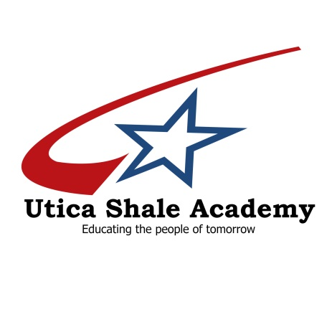

BOARD OF EDUCATION

Mike Biasi , President
Toni Dondzila
Dallas Sunders
Dr. Charles Joyce
William Pitts
Scott Wilson, Treasurer

38095 State Route 39

Dr. Mark Furda, Superintendent
330-420-5353
Rich Wright, Utica Shale Director
330-303-5858
Salineville, Ohio 43945
330-303-5858
Fax 330-679-3005
www.uticashaleschool.com

CORE CURRICULUM NOTIFICATION

Ohio Revised Code 3313.6014 requires that Utica Shale Academy advise students and their parent/guardian that failure to complete CORE CURRICULUM REQUIREMENTS will result in the student’s ineligibility to enroll in most state universities in Ohio without further coursework

3313.6014, 3313603

